

**LAB FILE**

**Web Programming with Python and JavaScript Lab**

**(SEC 035)**

**SUBMITTED BY:**

**ADEELA AZEEZ**

**SUBMIITED TO:**

**DR. TANVI CHAWLA**

**ROLL NUMBER: 2301010282**

**COURSE: BTECH CSE CORE**

**SECTION: E**

**School of Engineering & Technology**

**K. R. MANGALAM UNIVERSITY**

**Sohna, Haryana 122103, India**

**EXPERIMENT 12**

**Flask programs that render HTML pages using different techniques**

***Experiment 12.1: Basic HTML Rendering***

from flask import Flask, render_template_string

app = Flask(__name__)

@app.route('/')

def home():

html = """

<html>

<head><title>Home</title></head>

<body>

<h1>Welcome to Flask</h1>

<p>This is a basic HTML page.</p>

</body>

</html>

"""

return render_template_string(html)

if __name__ == '__main__':

app.run(debug=True)

**Output:**

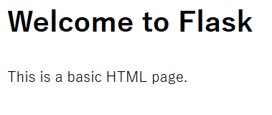

***Experiment 12.2: Rendering HTML from a Template File***

**app.py**

from flask import Flask, render_template

app = Flask(__name__)

@app.route('/')

def home():

return render_template("index.html")

if __name__ == '__main__':

app.run(debug=True)

**templates/index.html**

<!DOCTYPE html>

<html>

<head>

<title>Flask Template</title>

</head>

<body>

<h1>Welcome to Flask!</h1>

<p>This is a page rendered from an HTML template.</p>

</body>

</html>

**Output:**

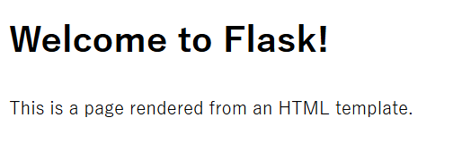

***Experiment 12.3: Passing Data to HTML Template***

**app.py**

from flask import Flask, render_template

app = Flask(__name__)

@app.route('/')

def home():

user = "John Doe"

return render_template("welcome.html", username=user)

if __name__ == '__main__':

app.run(debug=True)

**templates/welcome.html**

<!DOCTYPE html>

<html>

<head>

<title>Flask Variables</title>

</head>

<body>

<h1>Hello, {{ username }}!</h1>

<p>Welcome to your personalized Flask page.</p>

</body>

</html>

**Output:**

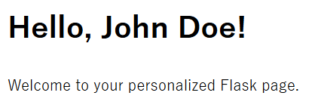

***Experiment 12.4: Rendering a List in an HTML Template***

**app.py**

from flask import Flask, render_template

app = Flask(__name__)

@app.route('/')

def home():

items = ["Apple", "Banana", "Cherry", "Date"]

return render_template("list.html", items=items)

if __name__ == '__main__':

app.run(debug=True)

**templates/list.html**

<!DOCTYPE html>

<html>

<head>

<title>Flask List</title>

</head>

<body>

<h1>Fruit List</h1>

<ul>

{% for item in items %}

<li>{{ item }}</li>

{% endfor %}

</ul>

</body>

</html>

**Output:**

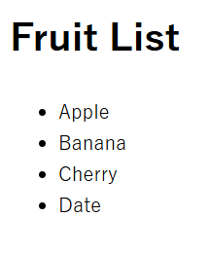

***Experiment 12.5: Rendering a Form and Processing Input***

**app.py**

from flask import Flask, render_template, request

app = Flask(__name__)

@app.route('/', methods=['GET', 'POST'])

def form():

if request.method == 'POST':

name = request.form['name']

return render_template("greeting.html", name=name)

return render_template("form.html")

if __name__ == '__main__':

app.run(debug=True)

**templates/form.html**

<!DOCTYPE html>

<html>

<head>

<title>Flask Form</title>

</head>

<body>

<h1>Enter Your Name</h1>

<form method="post">

<input type="text" name="name" required>

<input type="submit" value="Submit">

</form>

</body>

</html>

**templates/greeting.html**

<!DOCTYPE html>

<html>

<head>

<title>Greeting</title>

</head>

<body>

<h1>Hello, {{ name }}!</h1>

<p>Welcome to Flask!</p>

</body>

</html>

**Output:**

 